**Oxygen Saturation Technology (OSTTM) and Nano-bubbles comparison**

When oxygen saturation technology (OSTTM) was first developed, the opportunity to compare it with nano-bubble technology was provided for a small ½ -acre pond near Orlando, FL. The (stormwater) pond was partitioned into three sections: OST, nano-bubble, and control.

The OST was a first-generation unit with all components on shore and only suction and discharge headers in the water. The onshore components included a 2-Hp pump rated at 40 GPM and 70 ft head, all OST components, and a Topaz oxygen generator rated at 6 lpm at 90% nominal purity.

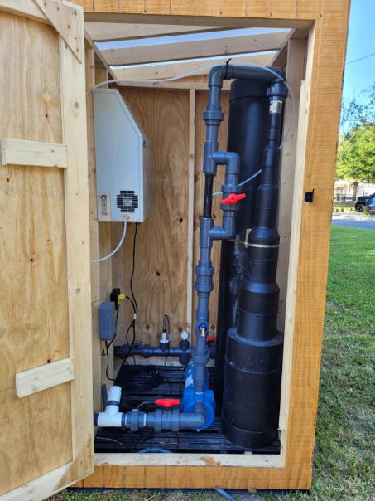

The nano-bubble unit was installed per manufacturer specifications.

The primary objective of this testing was to compare oxygen input from each system. Insite IG optical (fluorescent) dissolved oxygen (DO) probes were placed in-line with water flowing into and out of the nanobubble unit and on the inflow for the OST unit. A Hamilton Oxyferm FDA probe was connected to the OST outflow because the DO concentration exceeded the range of the InSiteIG probe. All probes were connected to a GWR Master data logger and programmed to collect hourly data.

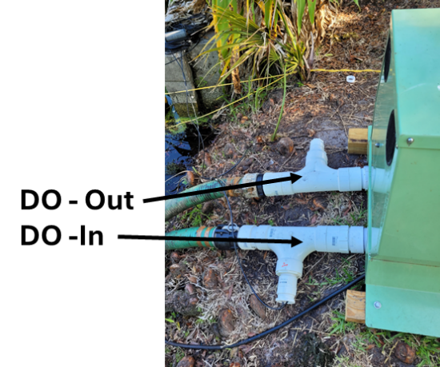 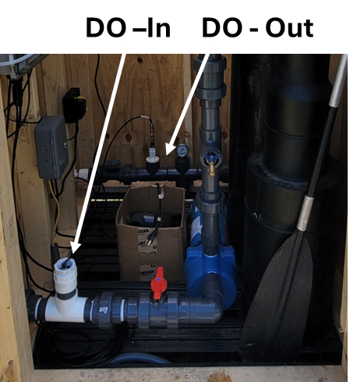

Data for a 24-hour period are shown below with nanobubble data in red and OST data in blue. Open data points represent inflow concentrations and solid data points represent outflow concentrations. The average DO increase across the nano bubble unit and OST systems were observed to be 4.75 and 28.7 mg/L respectively.

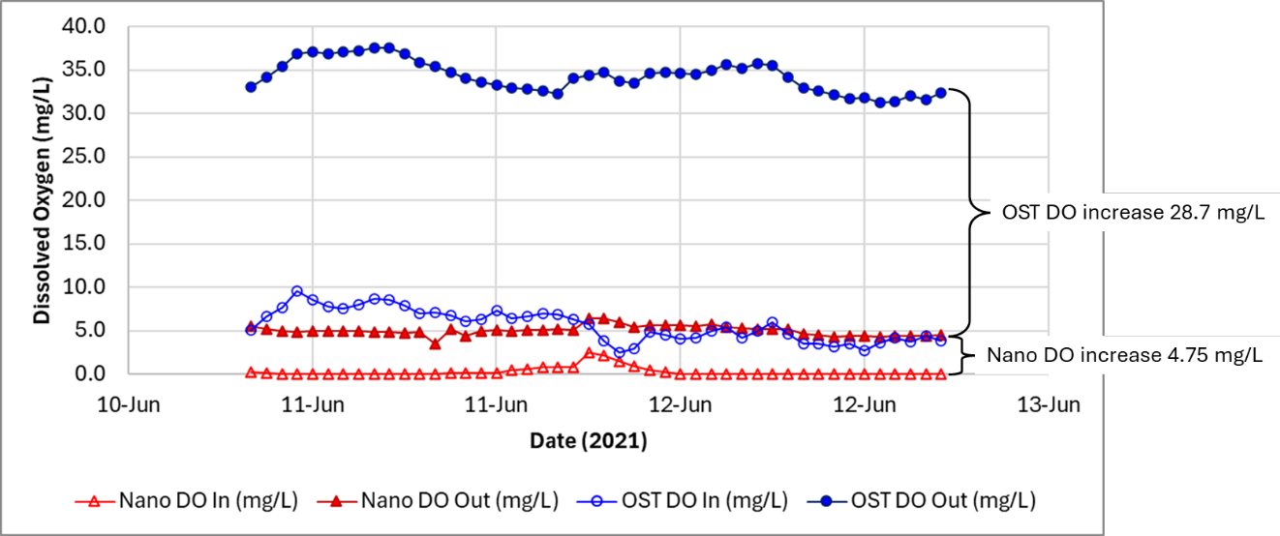

A second comparison of nano bubbles and OST is provided for a project near Manassas, VA. The client was operating two nano bubble units to manage DO for his pond to grow Tiger muskies.

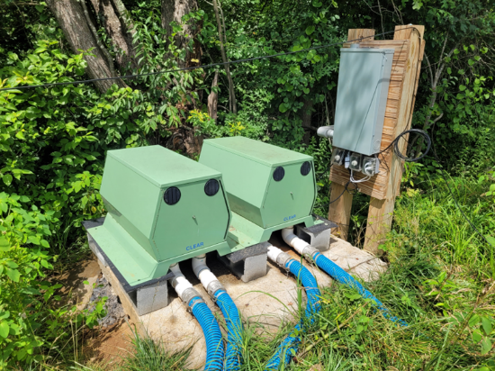



After a drastic increase in temperature from the nanobubble unit operation was observed, the client installed an OST. The OST unit was the same size described above.

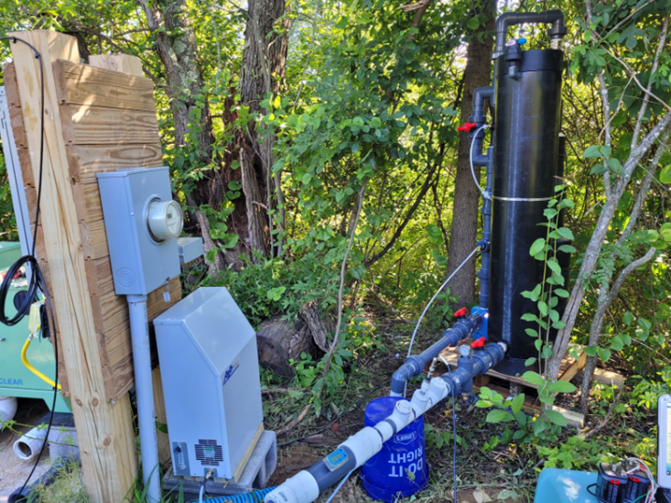

The client had two In-situ DO probes installed and was recording data hourly. The probes were positioned at the top and bottom of the water column, approximately ½ meter above the bottom and 1 meter below the surface.

Review of the data provided by the client showed approximately 5 °C temperature increase (~19-20 °C to > 25 °C) in bottom temperature in less than 5 days. Prior to the nano bubble unit operation background warming of bottom waters was observed to be approximately 0.11 °C/day. The OST unit was installed about 1 ½ weeks after the nano bubble unit was turned off. Temperatures in the bottom water following OST operation were observed to follow the same warming rate as background warming prior to the nanobubble unit operation. The data showed that OST operation did not affect thermal structure during operation. Operation of the nano bubble unit caused warming of the bottom waters ten times the background rate compared to OST not having any impact on natural warming of bottom waters.

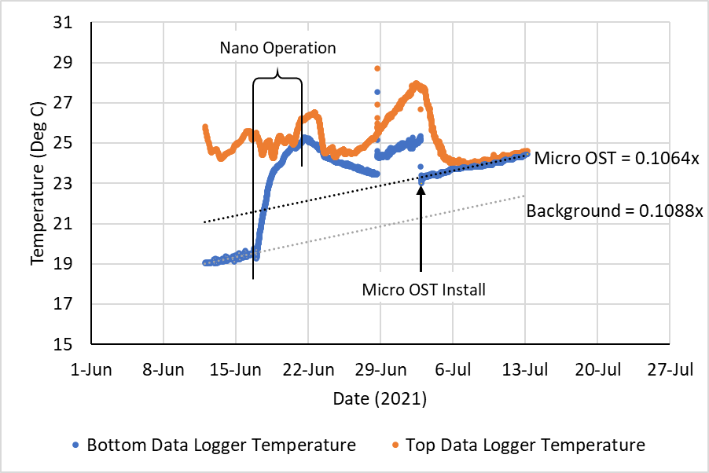

The first commercial installation of OST was on an 8-acre pond in Orleans, MA in spring 2021 to replace a nano-bubble system. This project was a demonstration project of oxygenation as a water quality management strategy on Cape Cod. The primary goal was to increase DO in bottom waters to maintain oxic conditions at the sediment-water interface to reduce/eliminate internal phosphorus loading causing harmful algal blooms. The project was reviewed by an independent source, Ken Wagner of Water Resource Services.

It was reported that “*The first two years of experimentation with a nanobubble system did not achieve goals and indicated that the installed equipment was not adequate to counter the observed oxygen demand, thereby allowing phosphorus to be released from the sediment under low oxygen conditions and supporting continued cyanobacteria blooms. A sidestream supersaturation system (SSS), or oxygen saturation technology (OST) system, was installed in spring of 2021.”*

In 2023 it was reported that “*Overall, the OST system was very successful in 2023 in preventing cyanobacteria blooms in Sarah’s Pond through summer.*”

Temperature and DO data are provide for this past year. Numbers represent depth in ft. From the data, it was observed that DO at 17 ft (blue) was consistently higher than all other depths sans the mixing in the hypolimnion in late June. During that time, the hypolimnion was observed to be homogenous regarding temperature, hence the increase in DO at depths 13 ft to the bottom.

Temperature data shows no mixing and steady temperatures at each depth throughout the year.

